Dashboard Layout
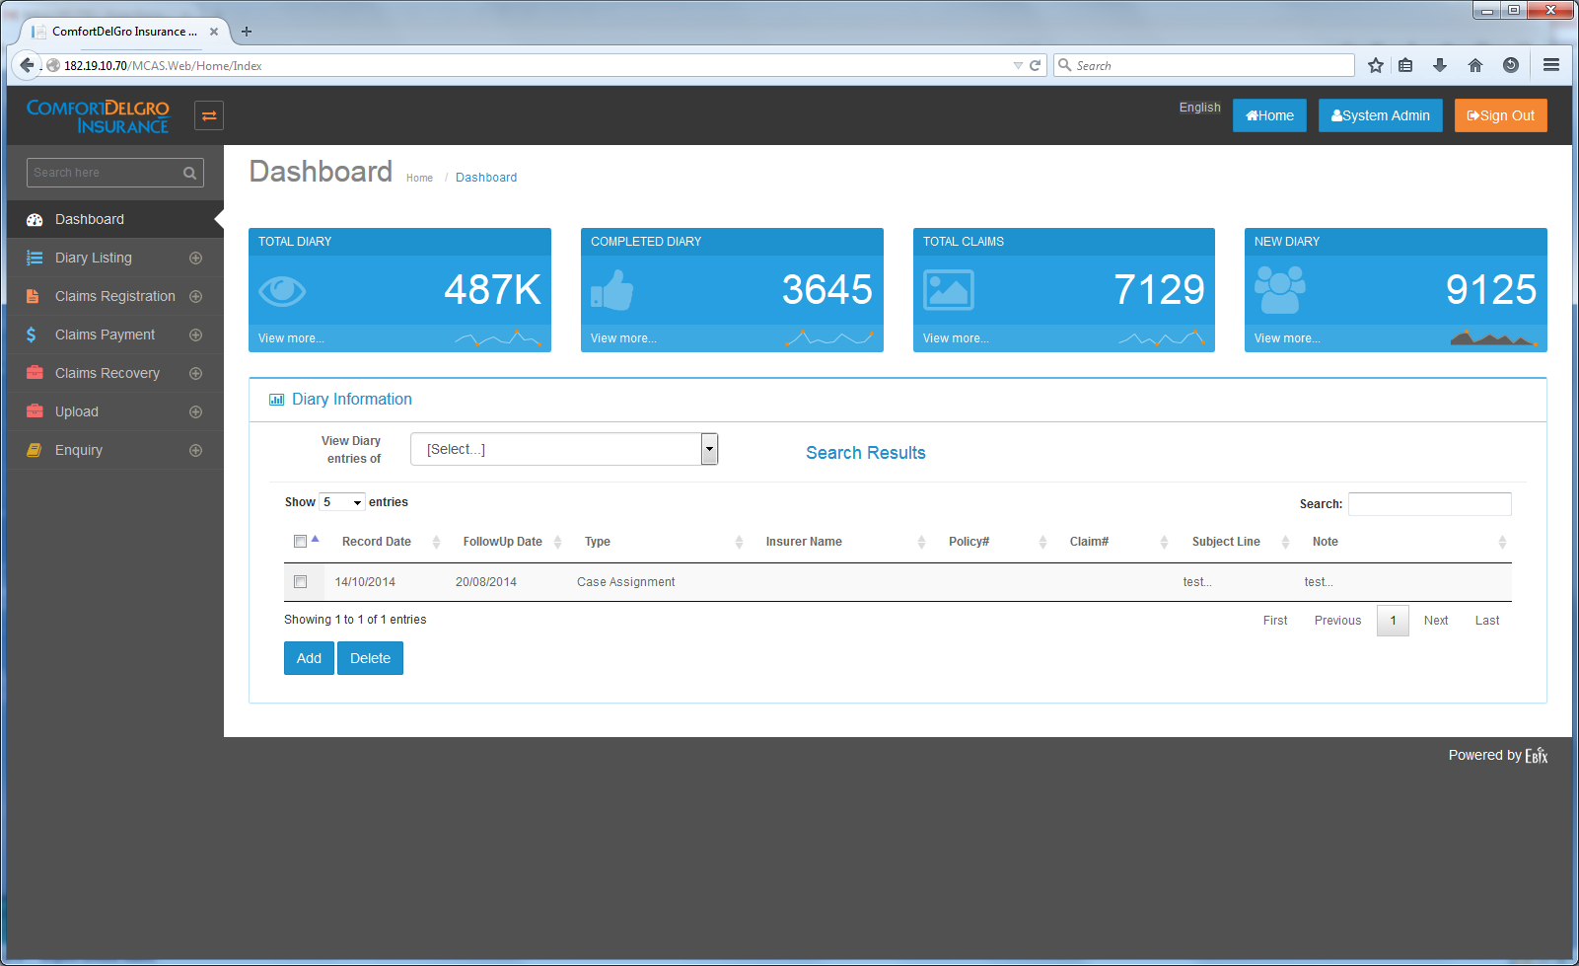
Changes Required:
Singapore (9 Jan 2015): Please ignore all greyed out text below.
The Dashboard is to be configurable for 2 different groups of users. Each group will be able to configure what they want to view on the Dashboard. Each group is allowed access to the following grids:
2 Groups of Users –
- Claim Officers
  - Tasks
  - Diaries
- Supervisors and Claim Officers with FAL
  - Tasks
  - Diaries
  - Mandate Requests
  - Payment Requests
- To display Five Sections: Tasks, Diary, Reassigned Diary, Escalation Diary, Mandate Approval (for Supervisor Group), Payment Approval (for Supervisor Group only)
[Varun 24 Dec. 14]
- We are already having listing functionality of diaries in dashboard screen.
- Do we need to over write this screen functionality with new screen details or just change columns of existing screen and put it under diary section?
Is user able to change the type of data to be displayed in display sections? i.e. Task section change into Payment made for the month.
[Varun 24 Dec. 14]

- Can we put expand / Collapse and Hide functionality for each section as a solution of user customization as per their needs?

Can user track the following so as to assist them in meeting their KPI
- Monthly no. of TPPD/TPBI claims settled.
- Monthly amount paid for TPPD/TPBI Claims, including amount in payment requests pending approval,
- Monthly amount recovered for Recovery Claims
- Or any other type of indicators to assist them in meeting their KPI.
[Varun 24 Dec. 14]

- We need to discuss these requirements in meeting for more understanding as below mentioned tables of sections required do not cover above mentioned KPIs points.
- To display Highlighted Colors for each entries - yellow/green when it is 3 days before Action Due Date and Red when the current date is past the Action Due date.
[Varun 24 Dec. 14]
- Colouring functionality can be provided as per currently running functionality in Task screen under claim registration screen.
- Please check and give confirmation for the same.
- To have sorting for each Column.
[Varun 24 Dec. 14]
- yes
- The possibility for users to rearrange the five sections by moving the section up or down
[Varun 24 Dec. 14]
- yes
- To have five blue boxes to provide overview of the number of items – have options to display e.g. Total Number, Number of Tasks due in 30 Days?
Is the number of different displayed sections at any one time in the dashboard capped at 5? If the number of different sections is not capped at 5, what is the maximum number of different sections allowable?
[Varun 24 Dec. 14]
- Please provide UI details to display five boxes having totals .

Column Headers:
Tasks:
S/No. | Claim No. | Claimant Name | Action Due | Close Date | Modified Date | Prompt Details | Action
 |  |  |  |  |  |  | << Select >>
Note: Clicking Select will bring user to the Task Screen of the particular Claim No.

Diary:
S/No. | Claim No. | Claimant Name | Diary Description | Created By | Estimated Completion Date | Action
 |  |  |  |  |  | << Select >>

Reassigned Diary:
S/No. | Claim No. | Claimant Name | Diary Description | Created By | Previous CO In-Charge | Estimated Completion Date | Reassigned By | Action
 |  |  |  |  |  |  |  | << Select >>

Escalation Diary:
S/No. | Claim No. | Claimant Name | Diary Description | Created By | Estimated Completion Date | Action
 |  |  |  |  |  | << Select >>

Mandate Approval:
S/No. | Claim No. | Claimant Name | Claim Type | Mandate Request Date | Total Mandate Amount Requested | Action
 |  |  |  |  |  | << Select >>

Payment Approval:
S/No. | Claim No. | Claimant Name | Claim Type | Payment Request Date | Total Payment Amount Requested | Action
 |  |  |  |  |  | << Select >>

